### **Task Description**

Create a dynamic form using React that allows the user to add input fields dynamically. When the user clicks the "Add" button, a new input field is generated and displayed. This form also allows users to remove any added input fields.

### **Task Output Screenshot**

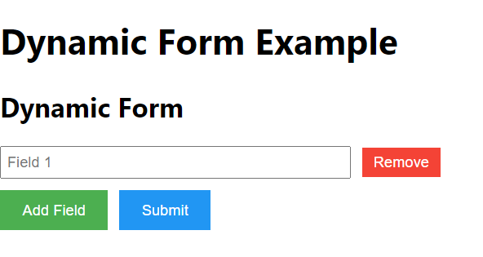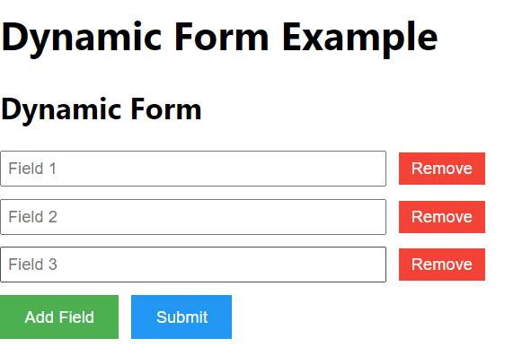

### **Widget/Algorithm Used in Task**

* **React Components**: The form is created using functional components in React. Each input field is rendered dynamically based on the current state.
* **useState Hook**: Used to maintain the list of input fields. The state is updated every time the user adds or removes an input field.
* **Button Widget**: A button labeled "Add" is used to allow users to add a new input field. A "Remove" button is also added next to each input field to allow deletion.
* **Array State Management**: The input fields are stored in an array, where each new input field is appended to the array upon clicking the "Add" button. Similarly, the selected field is removed from the array when the "Remove" button is clicked.
* **CSS**: Used to style the form and input fields, ensuring that they appear neatly and are easy to interact with.